To create Amazon EFS Replication

Objective:

To use Amazon EFS replication to create a replica of your Amazon EFS file system in the AWS Region of your preference

Background:

When you enable replication on an EFS file system, Amazon EFS automatically and transparently replicates the data and metadata on the source file system to a new destination EFS file system. To manage the process of creating the destination file system and keeping it synced with the source file system, Amazon EFS uses a replication configuration.

Amazon EFS automatically keeps the source and destination file systems synchronized. Amazon EFS replication is continual and designed to provide a

recovery point objective (RPO) and a recovery time objective (RTO) of minutes.

These features should assist you in meeting your compliance and business

continuity goals

solution:

Let us Create an EFS file systemCreate an EFS file system.

1. Go to the AWS and then for EFS . select create “file system” option on the screen.

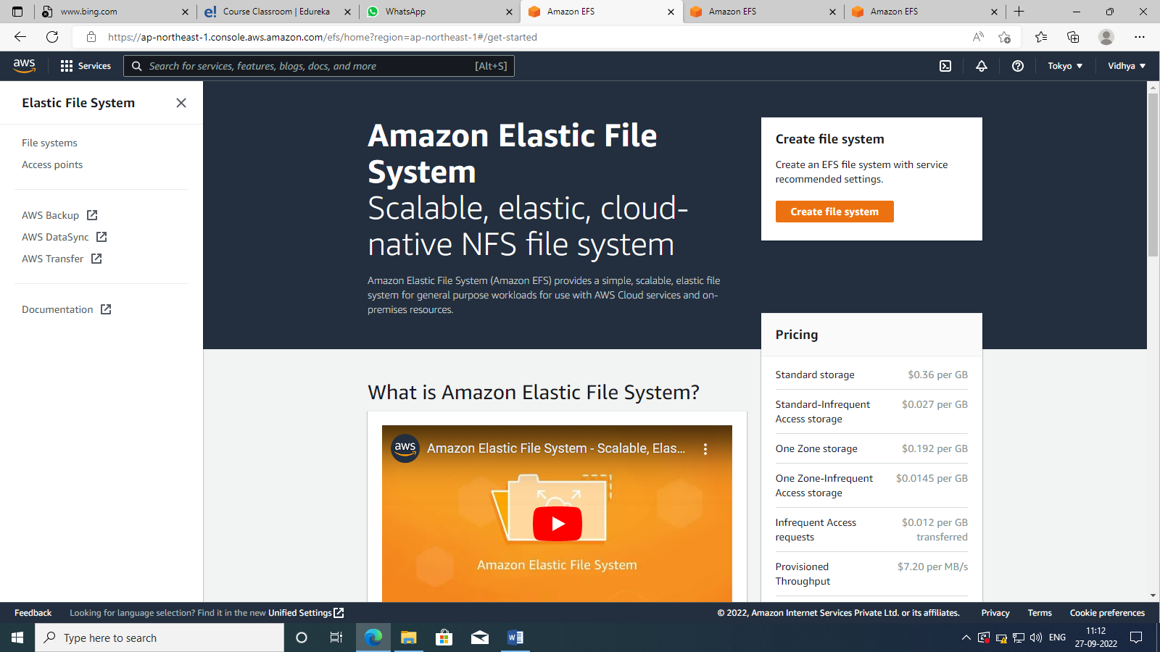

1. It will ask to give a name for your file system.(optional).let us take the vpc as default,then choose your storage data as you like.
2. Then opt for create option.
3. 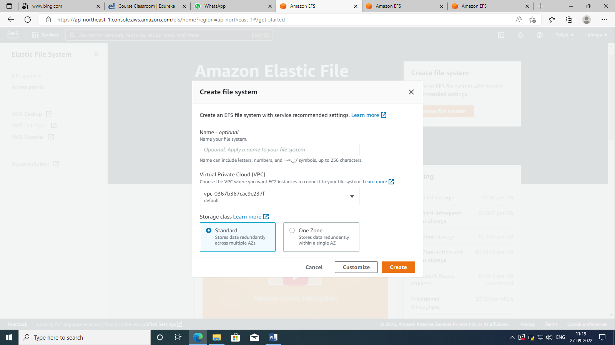
4. Click on the name of the file .as shown 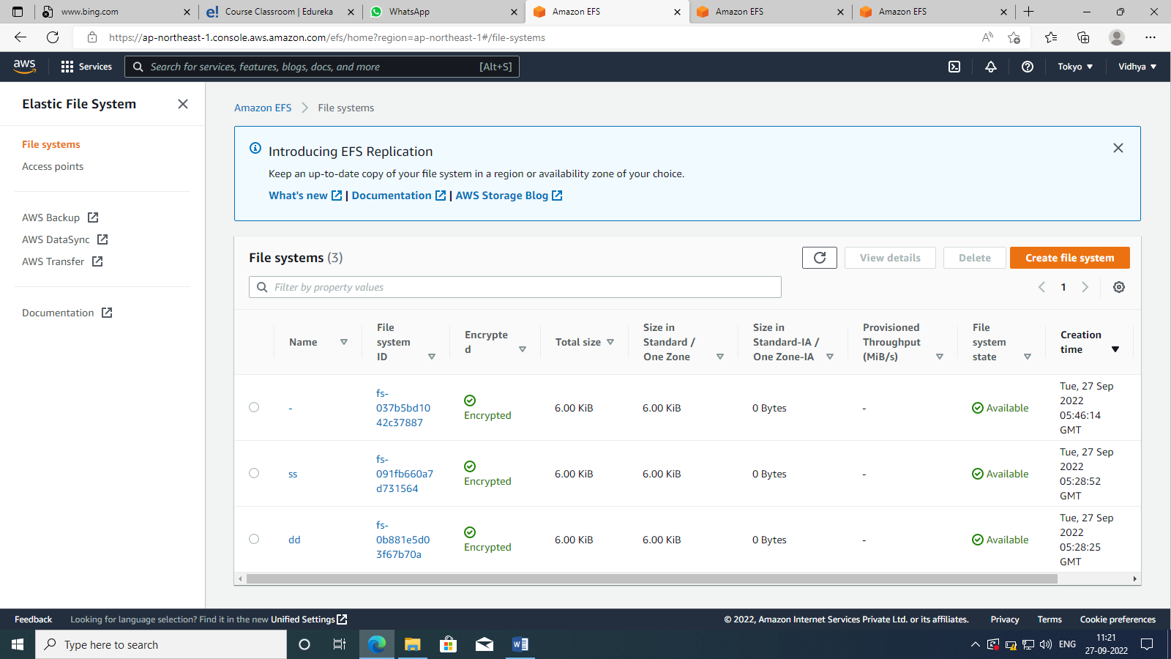
5. Then start with the replication process. Click on create replication .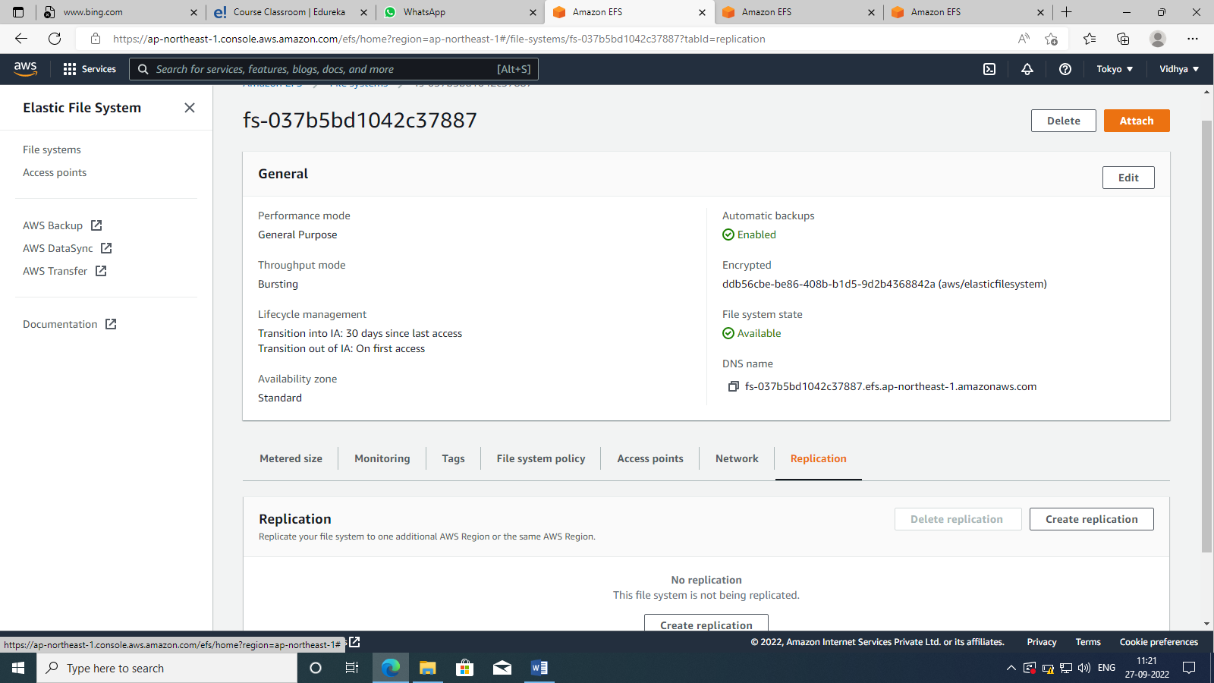
6. Select the region ,create aws kms key (optional).the click on create replication. 